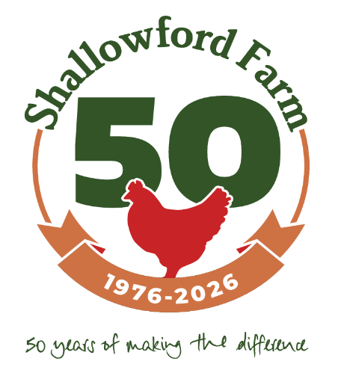

Brief for Consultant: The Shallowford Trust: Sowing Seeds for the Future
Delivery of Digital Communications.

Project Overview: The Shallowford Trust is a charity based at East Shallowford Farm in Dartmoor National Park that delivers nature-based experiences on a working farm for people of all backgrounds, with a particular focus on deprived communities who would not normally have this opportunity to access the nature. Our aim is to provide accessible and holistic experiences that improve mental health, well-being and environmental awareness; expand horizons and improve personal confidence.

We have successfully secured funding from the National Lottery Heritage Fund for our project: Sowing Seeds for the Future. The project has several elements: to improve management of our wet valley habitats to support a healthier population of the globally threatened marsh fritillary and other key species: to raise awareness amongst visiting groups of this important habitat and species: and to recruit, train and support volunteers to help us deliver our work. 2026 marks the 50th Anniversary of the founder of the Trust purchasing East Shallowford Farm and 50 years of groups visiting from our longstanding partner Providence House youth club in Battersea. We want to use this opportunity to raise awareness and celebrate what the Trust has achieved over 50 years but crucially to look forward positively to the next 50 years with renewed vision and hopefully increased support for our work.

We are seeking a consultant to develop and manage digital communications and social media campaigns to raise awareness, engage potential beneficiaries and supporters, and highlight the positive impacts of our programmes. https://www.shallowfordfarm.co.uk

Key Objectives
- Increase Awareness: Promote our charity’s mission, the importance and impact of our nature-based experiences.
- Engage Community: Create content that resonates with individuals or groups in deprived areas and encourages participation in our programs. Update and optimise our WordPress website. Produce newsletters for our supporters.
- Drive Donations and Support: Showcase the impact of our work facilitating fundraising and volunteer recruitment.
- Build a Supportive Online Community: Foster a sense of belonging and engagement with our cause on social media and Friends of Shallowford platform.
- Highlight Impact: Share success stories, testimonials, and the positive effects of our programs on participants.
- Support our staff: Work with our team to help develop skills to continue this work beyond the end of the project.

Target Audience
- Individuals, families, youth and community groups, and school from deprived communities who may benefit from nature-based experiences.
- Potential donors and supporters who care about the future of natural environment, young people, mental health, and social equity.
- Volunteers and partners in the charitable and environmental sectors.
- Policymakers

Scope of Work
Work with our team to develop and manage our digital communications across all social media channels in line with our ambition to promote the work of our charity by building followers and increasing engagement. We anticipate the role will be for approximately 7 hours spread across a working week, with a degree of flexibility with scope to be available for key events.

- Campaign Strategy
- Develop a comprehensive social media strategy that aligns with our charity’s goals and target audience and supports the Sowing Seeds for the Future project.
- Identify key messaging and content themes
- Recommend optimal social media platforms (e.g., Facebook, Instagram, Twitter, LinkedIn) based on the target audience.
- Deliver one tone of voice for the charity across socials and website

- Content Creation
- Develop a content calendar for the campaign (minimum 12 months).
- Create engaging multimedia content, including posts, graphics, videos, and stories.
- Highlight personal stories and testimonials from individuals who have benefited from our programs.
- Emphasize the value of nature-based experiences in promoting mental health, well-being, and environmental connection.
- Provide a focus for celebrating 50 years at the farm (in 2026) and looking forward another 50 years

- Mentoring and supporting our team
- Support the staff team to develop their skills and understanding of social media for the Trust

- Monitoring & Reporting
- Track the performance of the campaign using analytics tools (e.g., Google Analytics, platform insights).
- Provide regular updates on campaign progress and performance, including engagement rates, follower growth, and conversions (donations, sign-ups).
- Deliver a final report with key metrics and recommendations for future campaigns.

Deliverables
- Social media strategy document.
- Content calendar for 12 months.
- Templates and other tools to ensure longer term delivery of clear marketing and communications
- Monthly performance reports during the campaign.
- Final campaign performance report with analysis and recommendations.

Timeline
- Applications in by 30 January 2026
- Project Start Date: February 2026
- Project Completion Date: August 2027 (tbc)

How to Apply: Please submit your proposal, including:
- A brief overview of your approach and methodology.
- Examples of similar projects you have worked on.
- A proposed timeline and breakdown of budget includes the cost of developing the campaign, content creation, advertising, and any other associated expenses.
- References or case studies from past clients.

Evaluation Criteria
- Relevant experience in social media campaigns for charities or similar organisations.
- Creative approach to engaging marginalized communities.
- Understanding of nature-based experiences and their value in mental health and community development.
- Proven track record in increasing engagement, donations, and volunteer sign-ups via social media.

Point of Contact: For questions or more information, please contact Fiona Lambeck at Shallowford Farm, fiona@shallowfordfarm.co.uk

